Title of the Paper (16pt Times New Roman, Bold, Centered)
(Leave two spaces here)

First Author^{1*}, Second Author² and Third Author³
¹ Full address of first author including affiliation
² Full address of second author including affiliation
³ Full address of third author including affiliation
*Corresponding author: author@university.edu.
(use 12pt Times New Roman and Centered)

(Leave two spaces here)

ABSTRACT (Capitalize, Centered & Italicize)
This is a sample of the format of your paper. A minimum of 7 A4-sized pages (21 x 29.7 cm) pages with top, bottom left and right margins of 2.54 cm. Use a single space. Use 10pt size Times New Roman. Texts are justified.
(Leave one space here)
Keywords: Write your keywords (max 5) (Capitalize the first letter of the first keyword only, separate each keyword with a comma)

(Leave two spaces here)
- INTRODUCTION (14pt Times New Roman)
Body of the text should be in 12pt Times New Roman. Texts are justified.

(Leave two spaces here)
- LITERATURE REVIEW (14pt Times New Roman)
Body of the text should be in 12pt Times New Roman. Texts are justified.

(Leave two spaces here)
- METHODOLOGY (14pt Times New Roman)
Body of the text should be in 12pt Times New Roman. Mathematical Equations must be numbered as follows:

 | 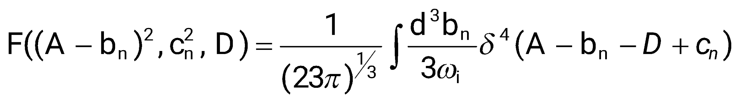 | (1)
where, | (1 line spacing here)
 | 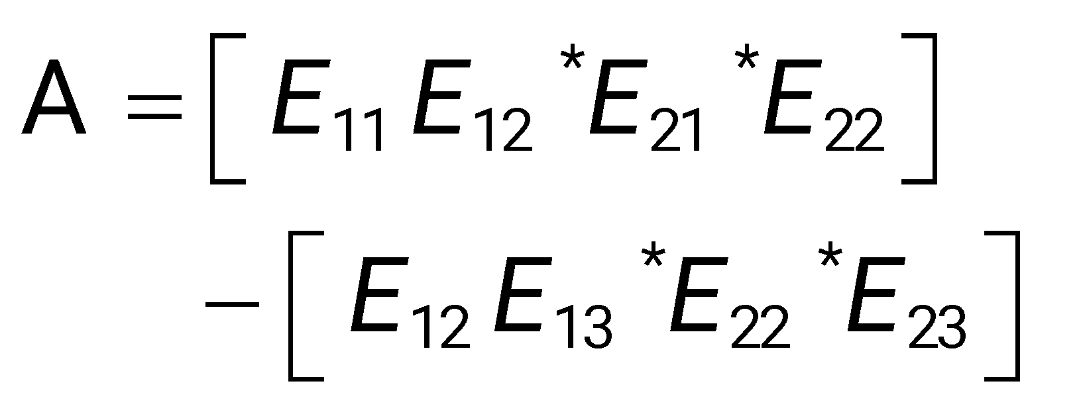 | (2)
(Leave one space here)
3.1 Subsection (12pt Times New Roman)
Body of the text should be in 12pt Times New Roman. Texts are justified.

(Leave two spaces here)
- EMPIRICAL RESULTS (14pt Times New Roman)
Body of the text should be in 12pt Times New Roman. Figures and Tables should be numbered as follows: Figure 1:, Figure 2: .. etc., Table 1:, Table 2:,.. etc. Texts are justified.
(Leave one space here)
4.1 Tables and figures
Tables and figures must be embedded into the texts and not supplied separately. Use 10pt Times New Roman. The title must be above the tables and below the figures. They should be kept to a minimum number of words and designed to be as simple as possible. Written texts use Arabic numerals and single spacing. The source should be mentioned for figures only.
(Leave one space here)

Table 1: The Title of the Table Capitalize the First Word (10pt Times New Roman)
ff | ff | ff | ff | ff
Ff1 | 12 | 43 | 24 | 34
ff | 12 | 34 | 56 | 6
ff | 21 | 23 | 12 | 34
ff | 11 | 22 | 33 | 44

Figure 1: The Title of the Figure Capitalize the First Word (10pt Times New Roman)
Source: Extracted and modified from … (10pt Times New Roman)

(Leave one space here)
4.2 List
Lists can be provided using either numbers or bullets:
- List item 1 like this;
- List item 2 is an example of a longer list item that wraps to a second line, where the second line is indented.

An example for bulleted items like this:
- List item 1;
- List item 2.

(Leave two spaces here)
- CONCLUSION (14pt Times New Roman)
Please, follow our instructions faithfully, otherwise you have to resubmit your full paper. Texts are justified.

(Leave two spaces here)
REFERENCES (14pt Times New Roman)
Use 12pt size Times New Roman, Single spacing, APA Style for all books, journal, proceeding, etc. citation.

JOURNALS, MAGAZINES, NEWSPAPERS IN PRINT FORMAT
General Form
Author, A. A., Author, B. B., & Author, C. C. (Year). Title of article. Title of Journal, xx, xxx-xxx.

One Author
Williams, J. H. (2008). Employee engagement: Improving participation in safety. Professional Safety, 53(12), 40-45.
Two to Seven Authors [List all authors]
Keller, T. E., Cusick, G. R., & Courtney, M. E. (2007). Approaching the transition to adulthood: Distinctive profiles of adolescents aging out of the child welfare system. Social Services Review, 81, 453-484.

Magazine Article
Mathews, J., Berrett, D., & Brillman, D. (2005, May 16). Other winning equations. Newsweek, 145(20), 48-59.

Newspaper Article with No Author and Discontinuous Pages
Generic Prozac debuts. (2001, August 3). The Washington Post, pp. E1, E4.

BOOKS, CHAPTERS IN BOOKS, REPORTS, ETC.

General Form
Author, A. A. (Year). Title of work. Location: Publisher.

One Author
Alexie, S. (1992). The business of fancy dancing: stories and poems. Brooklyn, NY: Hang Loose Press.

Corporate Author with an Edition and Published by the Corporate Author
American Psychiatric Association. (1994). Diagnostic and statistical manual of mental disorders (4th ed.). Washington, DC: Author.

Anonymous Author
Dorland’s illustrated medical dictionary (31st ed.). (2007). Philadelphia, PA: Saunders.

Chapter in a Book
Booth-LaForce, C., & Kerns, K. A. (2009). Child-parent attachment relationships, peer relationships, and peer-group functioning. InK. H. Rubin, W. M. Bukowski, & B. Laursen (Eds.), Handbook of peer interactions, relationships, and groups (pp. 490-507). New York, NY: Guilford Press.

ERIC Document
Shyyan, V., Thurlow, M., & Liu, K. (2005). Student perceptions of instructional strategies: Voices of English language learners with disabilities. Minneapolis, MN: National Center on Educational Outcomes, University of Minnesota. Retrieved from the ERIC database. (ED495903)

ONLINE JOURNALS, MAGAZINES, NEWSPAPERS

General Format - Databases
Author, A. A., Author, B. B., & Author, C. C. (Year). Title of article. Name of Journal, xx, xxx-xxx. doi:xxxxxxxxx
Article from an Online Magazine
Lodewijkx, H. F. M. (2001, May 23). Individual-group continuity in cooperation and competition. Current Issues in Social Psychology, 6(12), 166-182. Retrieved from http://www.uiowa.edu/~grpproc/crisp/crisp.6.12.htm

OTHER ONLINE RESOURCES

General Form
Author, A. A. (Year). Title of work. Retrieved from web address.

Online Report from a Nongovernmental Organization
Kenney, G. M., Cook, A., & Pelletier, J. (2009). Prospects for reducing uninsured rates among children: How much can premium assistance programs help? Retrieved from Urban Institute website: http:// www.urban.org/url.cfm?ID=411823

Online Report with No Author Identified and No Date
GVU's 10th WWW user survey. (n.d.). Retrieved from http://www.cc.gatech.edu/user_surveys/survey-1998-10/4

REFERENCE CITATIONS IN TEXT– APA utilizes a system of the brief referencing in the text of a paper, whether one is paraphrasing or providing a direct quotation from another author’s work. Citations in the text usually consist of the name of the author(s) and the year of publication. The page number is added when utilizing a direct quotation.

Indirect Quotation with Parenthetical Citation
Libraries historically highly value intellectual freedom and patron confidentiality (LaRue, 2007).

Indirect Quotation with Author as Part of the Narrative
LaRue (2007) identified intellectual freedom and patron confidentiality as two key values held historically by libraries.

Direct Quotation with Parenthetical Citation
Darwin used the metaphor of the tree of life "to express the other form of interconnectedness–genealogical rather than ecological" (Gould & Brown, 1991, p. 14).

Direct Quotation with Author as Part of the Narrative
Gould and Brown (1991) explained that Darwin used the metaphor of the tree of life "to express the other form of interconnectedness– genealogical rather than ecological”(p. 14).

CITING SECONDARY SOURCES -- When citing in the text a work discussed in a secondary source, give both the primary and the secondary sources. In the example below, the study by Seidenberg and McClelland was mentioned in an article by Coltheart, Curtis, Atkins, & Haller.

Seidenberg and McClelland’s study (as cited in Coltheart, Curtis, Atkins, & Haller, 1993) provided a glimpse into the world.

In the references page, you would cite the secondary source you read, not the original study.

Coltheart, M., Curtis, B., Atkins, P., & Haller, M. (1993). Models of reading aloud: Dual-route and parallel-distributed processing approaches. Psychological Review, 100, 589-608.

