**INTEGRATING ENVIRONMENTAL, SOCIAL AND GOVERNANCE (ESG) INTO SHARIAH COMPLIANT FUND INVESTMENT PORTFOLIOS: LEGAL AND REGULATORY INITIATIVES IN MALAYSIA**

**SURIANOM MISKAM**

Faculty of Syariah and Law

Kolej Universiti Islam Antarabangsa Selangor (KUIS)

surianom@kuis.edu.my

**MARLIANA ABDULLAH**

Faculty of Syariah and Law

Kolej Universiti Islam Antarabangsa Selangor (KUIS)

marliana@kuis.edu.my

**ABSTRACT**

*The Environmental, Social and Governance (ESG) investing and Shariah compliant investing generally share common objectives in that they promote social values. The ESG intiatives include a range of issues related to company activities in environmental, social relations and corporate governance aspects to promote sustainable business practices. Shariah compliant investing, which is based on the prohibition of riba, maisir and gharar, also applies negative sreening process when dealing with industries such as tobacco, alcohol, weapon as well as other non-halal products. Thus, integrating ESG elements into Shariah investing is consistent with the fundamental Shariah principles that promote equality, social justice and financial inclusion. However, there are few funds that combine the elements of ESG and Shariah compliance that are available for Malaysian retail investors in the market currently. Of more than 600 unit trust funds managed in Malaysia, only five are ESG Shariah compliant funds. On this point, the government and the regulators in Malaysia are becoming more ESG-focused and have developed the Socially Responsible Investment (SRI) Roadmap by having policies and framework that promotes ESG initiative in order to attract fund managers and investors. Thus, this paper will examine the legal and regulatory initiatives taken by the policy maker and regulator in promoting ESG initiatives. The methodology adopted in this article is a document analysis of the relevant legislations and policies.*

***Keywords****: ESG, SRI, Shariah Compliant Investment, Legal and Regulatory, Shariah Screening*

**INTRODUCTION**

Environmental, Social and Governance (ESG) components are central factors within the context of sustainability. There are numerous classifications of ESG based on categories such as climate change, environment, ethical, governance, social impact, responsible and sustainable investments, including the use of different acronyms (World Bank, 2018). ESG investing and Shariah compliant investing generally share common objectives in that they promote social values. The ESG initiatives include a range of issues related to company activities in environmental, social relations and corporate governance aspects to promote sustainable business practices.

**METHODOLOGY**

This study is legal research by applying a content analysis technique to fulfil the objectives of this study.

**LITERATURE REVIEW**

The term ESG was first coined in 2005 in a landmark study entitled “Who cares Wins” by the UN Global Compact. ESG investing is a type of ‘sustainable investing’ which is an umbrella term for investment portfolios that, while seeking positive returns, also take into account and evaluate the long-term impact of business practices on society, the environment and the performance of the business itself (Al Ansari & Alanzarouti, 2020).

Schroders’ Environmental, Social and Governance Policy defines ESG investing to cover the range of investment activities which recognise the relationship between companies, the societies and environments in which they operate, and between companies and the shareholders which have control over them. ESG integration looks at investment decisions in a wider context than traditional financial analysis and explicitly includes analysis of a range of risks and opportunities related to ESG consideration (Schroders, 2019).

**ANALYSIS AND DISCUSSION: LEGAL AND REGULATORY INITIATIVES IN MALAYSIA**

The initial development of the Islamic funds industry also marked the start of the Malaysian capital market’s involvement in SRI as the Shariah principles underlying Islamic investing have significant commonalities with the principles underlying SRI. Islamic funds are also recognised as sustainable investments as Shariah principles promote the pursuit of positive social outcomes alongside commercial returns. In addition, Islamic investing is often associated with ethical practices and require the application of screening (Securities Commission, 2017).

***Legal and Regulatory Initiatives***

The following section examines the legal and regulatory initiatives taken by the policy maker and regulator in promoting ESG initiatives in Malaysia:

**Malaysian Capital Market Master plan 2 (CMP2) 2011**

The development of sustainable investment for the Malaysian capital market can be traced back to the introduction of the Malaysian Capital Market Master plan 2 (CMP2) by the Securities Commissions in 2011. The CMP2 has placed greater emphasis on socially responsible financing and investments in order to encourage intermediaries and public-listed companies to give greater consideration to social and environmental issues. The CMP2 strategy is supported by the introduction of the SC’s 5i strategy to facilitate sustainable investment ecosystems. The 5i was later embedded in the Sustainable and Responsible Investment Roadmap, which chart the role of the capital market in driving Malaysia’s sustainable development plans from 2019 to 2023.

In determining whether or not a fund fulfils the requirements of the Guidelines, reference must be made to SRI strategies provided under the Guidelines as shown in Table 1.1.

**Table 1:** SRI Strategies

|  |  |
| --- | --- |
| Strategy | Description |
| Negative screening | Exclusion of companies undertaking certain business activities or practices from a portfolio based on specific environmental. Social or governance criteria including Shariah screening methodology. |
| Positive screening | Prioritising investment in companies or projects that demonstrate positive environmental, social or governance performance relative to industry peers. |
| ESG integration | Systematic assessment of quantitative and qualitative data on environmental, social and governance factors in investment analysis. |
| Thematic integration | Selection on investments that align with specific themes related to sustainability. |
| Impact or social investing | Targeted investments with intent to solve social or environmental issues, or investments towards business and projects with a clear social or environmental purpose. |

**Figure 1**: Statistik Pembiayaan Islam 2015-2017

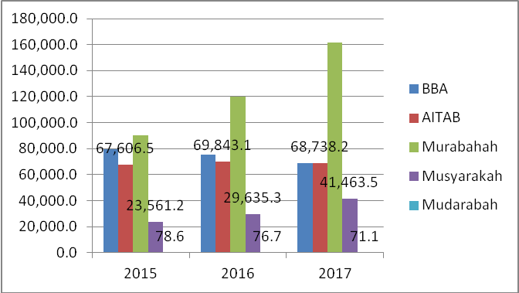

(Source: Bank Negara Malaysia, 2017)

**CONCLUSION**

It is submitted that encouraging legal and regulatory initiatives and the growing recognition of Islamic-ESG values by asset managers in the Islamic fund industry are giving a boost to responsible finance. The Shariah-compliant SRI fund sector is also expected to expand by virtue of the rising demand from value-based investors. This is illustrated by increasing evidence that ESG-integrated investment portfolios tend to outperform the market. In line with the government’s continuous efforts to increase the number of green companies, public awareness on the similarities of Islamic finance and ESG/green finance should therefore be emphasised. This will encourage companies to be listed as both Shariah-compliant and ESG entities. Towards achieving these objectives, relevant parties would need to work together and establish relevant frameworks in line with the objective.

**ACKNOWLEDGEMENT**

**REFERENCE**

Abdul Kadir, M.A.B. et al. (2019). Malaysian Social Enterprise Blueprint 2015-2018: What’s

Next? ASEAN Entrepreneurship Journal (AEJ) Vol 5 No 2 ISSN: 2637-0301

Bank Negara Malaysia. 2018. Strategy Paper on Value-Based Intermediation 2018 (BNM/RH/DP 034–2)

Chowdhury, M. A. F. and Mansur, M. (2015). Socially Responsible Investment And Shariah-

Compliant Investment Compared: Can Investors Benefit From Diversification? An ARDL approach. Munich Personal RePEc Archive

Erragraguy, E. & Revelli, C. (2015). Should Islamic Investors Consider SRI Criteria In Their

Investment Strategies? Finance Research Letters 14 (2015) 11–19

Securities Commission of Malaysia (2020). Annual Report