**16**

**CLONING AND EXPRESSION OF HYPOTHETICAL PROTEIN TARGETS IN *Burkholderia pseudomallei* BY TRANSPOSON-DIRECTED INSERTION SITE SEQUENCING *(TraDIS)* TECHNIQUE**

Siti Marhamah Drahaman1, Mohd Firdaus Raih2, Noraslinda Muhamad Bunnori1 and Aisyah Mohamed Rehan1,3*

1Department of Biotechnology, Kulliyyah of Science, International Islamic University Malaysia, Indera Mahkota Campus, Jalan Sultan Ahmad Shah, 25200 Kuantan, Pahang, Malaysia

2School of Biosciences and Biotechnology, Faculty of Science and Technology and Institute of Systems Biology, Universiti Kebangsaan Malaysia, 43600 UKM Bangi, Malaysia

3Human Molecular & Cellular Biology Research Cluster (iMOLEC), Integrated Centre for Animal Care and Use, International Islamic University Malaysia, Indera Mahkota Campus, Jalan Sultan Ahmad Shah, 25200 Kuantan, Pahang, Malaysia

**ABSTRACT**

*Melioidosis is an infectious disease caused by a bacterium called Burkholderia pseudomallei found in contaminated water and soil. B. pseudomallei is naturally resistant to many commonly used antibiotics and thus current research efforts focus on prevention of disease and finding ways to reduce mortality. Identification of B. pseudomallei essential genes and its products may represent excellent targets for development of novel antimicrobial drugs. In this study, primers were designed for the PCR amplification of five target genes selected based on bioinformatics analysis from transposon-directed insertion site sequencing (TraDIS) library which compiles hypothetical proteins. Successfully amplified target genes were cloned into Gateway™ plasmid before being transformed into E. coli host. Expression trials of the target protein were performed for affinity tag protein purification. The presence of expressed soluble or non-soluble proteins were observed using SDS-PAGE electrophoresis. From this study, five selected target genes were successfully amplified using two-step PCR. One target gene, BPSL 2774 was successfully cloned into Gateway™ pDEST15 (GST-tagged) and purified using glutathione affinity protein purification kit. Mass spectrometry result has confirmed the presence of expressed and partially soluble GST-tagged protein of BPSL 2774. Using BLASTp search to PDB database and I-TASSER structure and function prediction softwares, BPSL 2774 is shown to have conserved domains of Glycosyltransferase GTB type superfamily and predicted to function as a glycosyltransferase. This enzyme is important in cell wall biosynthesis and transfer of sugar. This work provides the foundation for further investigation into the function of hypothetical protein BPSL2774, its possible role as a glycosyltransferase and as a potential virulence factor for B. pseudomallei.*

**Keywords:** *Melioidosis, B. pseudomallei, hypothetical proteins, GatewayTM cloning, protein purification and expression*

**1.0 INTRODUCTION**

Melioidosis is an infectious disease caused by a gram negative bacterium called *Burkholderia pseudomallei*. The bacterium can be found in contaminated water and soil. *B. pseudomallei* is a natural occupant of soil, stagnant water and rice paddies. Infections can occur by direct contact with the contaminated source either by ingestion, inhalation, or through wounds and abrasions. Melioidosis has been recognized as an important cause of sepsis in Southeast Asia and northern Australia [1]. Among important *B. pseudomallei* virulence factors that have been identified include: the outer membrane lipopolysaccharides [2]; secretory proteins e.g. lecithinase, lipase, hemolysin [1, 3, 4]; and iron siderophores [5] [reviewed by 6 and 7].

There is great concern of intrinsically resistant *B. pseudomallei* to many commonly used antibiotics [1, 8]. Beside the risk of re-infection [9], the bacterium is also able to persist as a chronic infection in surviving melioidosis patients and later reactivating itself, causing lethal relapse cases [10, 11]. Recent papers have reported the association of biofilm formation to the persistence of *B. pseudomallei* and relapsing melioidosis [12, 13].

The complex *B. pseudomallei* genome is composed of two chromosomes of 4.07 and 3.17 megabase pairs, respectively [14]. The large chromosome encodes for the core functions linked to the central metabolism and cell growth, whereas the small chromosome is linked to the accessory functions for niche adaptation and survival in challenging environments [14, 15]. The acquisitions of genomic islands via horizontal transfer in *B. pseudomallei* also contribute to the genetically and phenotypically diverse bacterial species [14, 15].

The identification of essential genes in *B. pseudomallei* will enable a fundamental understanding on the cellular mechanism and provide potential new targets for antimicrobial drug development. Besides wet experimental approach e.g. single gene detection, transposon mutagenesis, genetic footprinting and antisense RNA techniques, in silico prediction of essential genes has enabled a reliable and cost-effective means to discover new targets for therapeutics [16, 17]. Integrative analysis that combines genomics, transcriptional and proteomic for a systematic characterization of *B. pseudomallei* interaction with the environment has also been performed [18].

Recently, high-throughput sequencing technology has allowed large-scale transposon mutagenesis screening to identify transposon insertion sites efficiently. This aids the process of transposon-directed insertion site sequencing (TraDIS) and transposon sequencing (Tn-seq) techniques, which analyses large pools of mutants [19, 20].

Moule *et al.* has provided a compilation of *B. pseudomallei* putative essential genes that can be utilized as targets for antimicrobial development using TraDIS technique. Genes encoding hypothetical proteins or conserved hypothetical proteins that have not previously been established as essential were identified [21]. Hypothetical proteins are uncharacterized for their biochemical, biophysical, and/or cellular functions. We aim to identify and characterize several identified essential target genes from *B. pseudomallei* by performing gene amplification and directional cloning*.*

**2.0 EXPERIMENTAL**

**2.1 Bioinformatics Analysis**

The essential target genes were selected from the TraDIS library, published by Moule et al, 2014. From the list of 52 hypothetical proteins, five hypothetical protein targets were selected. Several bioinformatics analysis were conducted prior to selection. First, the gene and protein sequences were retrieved from genome database, geneDB *(http://www.genedb.org/Homepage*). Second, the searches for related protein sequences were conducted using the National Center for Biotechnology (NCBI) with Basic Local Alignment Search Tool (BLAST) against Protein Data Bank (PDB) to find regions of sequence similarity for the functional and evolutionary descriptions *(https://blast.ncbi.nlm.nih.gov/Blast*). Third, the signal peptide prediction using amino acid sequences to identify and locate the signal peptide cleavage sites were analyzed by SignalP 4.1 Server *(http://www.cbs.dtu.dk/services /SignalP/).*

**2.2 Primer Design**

For the directional cloning of inserts into the Gateway cloning system, nested PCR were conducted to flank the target sequences with attB recombination sequences using Gateway cloning protocols. This two-stage PCR used two sets of primers; i.e. gene specific primers (Table 1) and generic primers (Table 2). An rTEV protease-cleavage site was included in between the *att*B sequence and the original ORF translational start. The first round PCR amplification used the gene-specific primers to amplify the gene of interest. The second round amplification utilized the product from the first round as the template, and used generic primers to incorporate the *att*B sites required for the Gateway BP recombination reaction. The PCR product from each run was purified and quantified before being used for cloning.

**Table 1** Gene-specific primers used for the amplification of selected hypothetical protein gene constructs.

|  |  |  |  |  |
| --- | --- | --- | --- | --- |
| Constructs | Primer Sequences (5’-3’) | | Tm | %GC |
| *BPSL0089* | Forward | 5’ –GGC AGC GGC GCG ATG ACT GCA AAC GAG AAG AAA GAT CTC -3’ | 61.5 | 72.6 |
| Reverse | 5’ – GAA AGC TGG GTG TCA AGC ACG CTC TTT TGC AAG GTA TCG -3’ | 59.0 | 71.7 |
| *BPSL0588* | Forward | 5’-GGC AGC GGC GCG ATG CTC GTA GCT CTG CTG TCG ATT ATT -3’ | 70.9 | 59.0 |
| Reverse | 5’ -GAA AGC TGG GTG TTA CCC CTT ATT GCT CTT TCC TTG CCT GTC -3’ | 67.3 | 50.0 |
| *BPSL1690* | Forward | 5’ –TAT TTT CAG GGC AGC GGC GCG ATG CGC TCT GAT GCT GCC -3’ | 61.5 | 72.8 |
| Reverse | 5’ -GAA AGC TGG GTG TCA GGC TCC GGA ATG GAT GGC GGT -3’ | 61.1 | 71.2 |
| *BPSL1691* | Forward | 5’ -GGC AGC GGC GCG ATG AGT GAT TCT GTC AGT -3’ | 68.2 | 60.0 |
| Reverse | 5’ -GAA AGC TGG GTG TCA GAG CGC ATG ATC GGC -3’ | 67.3 | 60.0 |
| *BPSL2774* | Forward | 5’ –TTT CAG GGC AGC GGC GCG ATG AAA GTA TTC ATC CTT -3’ | 50.0 | 67.5 |
| Reverse | 5’ –GTA CAA GAA AGC TGG GTG TCA TCG CAC ACC TCG CAT -3’ | 52.8 | 67.5 |
|  |  |  |  |

**Table 2** Generic primers used for the amplification of Gateway recombination sites.

|  |  |  |
| --- | --- | --- |
| Constructs | Primer Sequences (5’-3’) | |
| Generic_Forward_attB1 | Forward | GGGG ACA AGT TTG TAC AAA AAA GCA GGC TTC GAA AAC CTG TAT TTT CAG GGC AGC GGC GCG |
| Generic_Reverse_attB2 | Reverse | GGGG AC CAC TTT GTA CAA GAA AGC TGG GTG |

**2.3 PCR Amplification**

Initially, gradient PCR was performed to optimize the annealing temperature for the specific primer used. Five different temperatures were tested within the range of (Tm - 10ºC)values for the forward and reverse primer. Gene-specific PCR was conducted using the most optimal annealing temperature. A purified PCR product at sufficient concentration was used as DNA template for the subsequent nested PCR, to incorporate the full attB sites to the target gene. The two-stage PCR cycle protocols using Primestar® HS DNA Polymerase (Takara) followed published PCR protocols [26].

The PCR product for each target gene was purified using PCR Cleanup Kit (Axygen). The procedure was performed as per kit instruction in the manual. PCR products were visualized with 1.0 % (w/v) agarose gel electrophoresis under UV light using 100bp plus ladder (Vivantis) as a length reference. DNA was quantified by using Nanodrop 2000 (Thermo Scientific, USA).

**2.4 Cloning**

Approximately 40 to 100 femtomoles (fmol) of purified PCR products were used for Gateway® BP recombination with pDONRTM221 (Life Technologies) using BP clonaseTM (Invitrogen, USA) to generate the entry clones. The recombination reaction was set up as specified in table 5.

**Table 5** BP recombination for Entry clone.

|  |  |  |
| --- | --- | --- |
| **Reagent** | **Final Concentration** | **Volume** |
| TE Buffer | 1 X | 1.5 µL |
| 5 X BP Clonase buffer mix | 1 X | 2.0 µL |
| *att*B PCR product | 100 fmol | 1.0 µL |
| pDONR221 | 150 ng/µL | 0.5 µL |

The components were added into a 1.5 ml microfuge tube and vortexed briefly. The mix was incubated at room temperature (~25ºC) for 18 hours. To terminate the reaction, 0.5 µL Proteinase K was added and incubated at 37ºC for 10 minutes.

Transformation was then performed by electroporation method. About 2.0 µL of the recombination products was added to 40 µL of *E. coli* DH5α cells (Life Technologies, USA). The mixture was pipetted into a pre-cold cuvette for electroporation step. 1 ml pre-warmed LB broth was added right after electroporation. Then, this mixture was incubated in 37 ºC, at 250 rpm for 1 hour before spread onto LB agar plate supplemented with 50µg/mL Kanamycin. The positive *att*L-flanked entry clones containing the gene of interest were screened by *Bsr*GI restriction digestion, colony PCR and sequencing. The product of Gateway® BP recombination was then undergo Gateway® LR recombination to create destination clones. The recombination reaction was set up as specified in table 6. The recombination product was then preceded with transformation before spread on LB agar plate in order to complete the cloning protocols using Gateway™ cloning system.

**Table 5** LR recombination for Destination clone.

|  |  |  |
| --- | --- | --- |
| **Reagent** | **Final Concentration** | **Volume** |
| TE Buffer | 1 X | 1.5 µL |
| 5 X LR Clonase buffer mix | 1 X | 2.0 µL |
| *att*L clone product | 25 fmol | 1.0 µL |
| PDEST15/pDEST17 | 150 ng/µL | 0.5 µL |

**2.5 Cell culture and lysis**

The cells were cultured using auto induction method (Studier, 2005). The cloned gene was transformed into expression strain, *E. coli* BL21(DE3) competent cell (Life technologies). The colony was inoculated in Minimal Non-Inducing Media (MDG) medium added with ampicilin before ncubated in 37 ºC at 200 rpm, overnight. MDG medium was further inoculated in Complex Auto-Inducing Media (ZYM) medium added with ampicilin and incubated in 37 ºC at 200 rpm for 4 hours, followed by at 18 ºC at 200 rpm, overnight*.* Then, the cell was harvested by centrifuged at 4000 rpm for 30 minutes at 4 ºC. The pellet was resuspended in cold Lysis Buffer (50 mM Tris-HCl pH8, 100 mM NaCl, 10 mM EDTA). The suspension was sonicated (Omni Sonic Ruptor 400) with sonication condition of 6 X 30 Seconds / 60 Seconds off, Amplitude 40 % (Kaltenbach et. al, 2015). After that, the lysed cell was centrifuged at 9000 rpm for 60 minutes at 4 ºC.

**2.6 Protein purification**

The insoluble protein was sedimented by centrifugation and the soluble protein in supernatant was filtered using syringe and 0.45 µM filter prior to protein purification. Protein purification was conducted using GST fusion protein purification kit (Genscript). 1 mL of glutathione resin was loaded into a disposable column. The resin bed was equilibrated with 200 µL of buffer A (wash buffer; 50 mM Tris-HCl, 100 mM NaCl, 1 mM EDTA) on spin column for 2 times. After equilibration, the filtered supernatant was loaded into the column. 600 µL of the filtered supernatant was loaded each time until 10 mL of the filtered supernatant finished using gravity flow. Then, 4 times of 600 µL of buffer A (wash buffer; 50 mM Tris-HCl, 100 mM NaCl, 1 mM EDTA) was loaded into the column and centrifuged for 30 sec at 2000 rpm. Lastly, 3 times of 200 µL of buffer B (elution buffer; 50 mM Tris-HCl, 100 mM NaCl, 1 mM EDTA, 0.154 g of reduced glutathione) was loaded into the column and centrifuged for 30 sec at 2000 rpm. All the flow through fractions was kept for SDS-PAGE electrophoresis in -80 ºC for further use. The purified protein was expressed in SDS-PAGE electrophoresis.

**3.0 RESULTS AND DISCUSSION**

**3.1 PCR amplification**

Five of the target genes were successfully amplified using Primestar® HS DNA Polymerase (Takara) and purified by AxyPrep PCR Cleanup Kit (Axygen) as illustrated in Figure 1. The primers used to amplify the 3′ end of the 5′ flanking sequence and the 5′ end of the 3′ flanking sequence of the target gene are 36–39 bases in length. The results of the present study showed the design of primers sets with similar Tm value may be crucial for positive DNA amplification, as well as the use of a good DNA Taq polymerase.

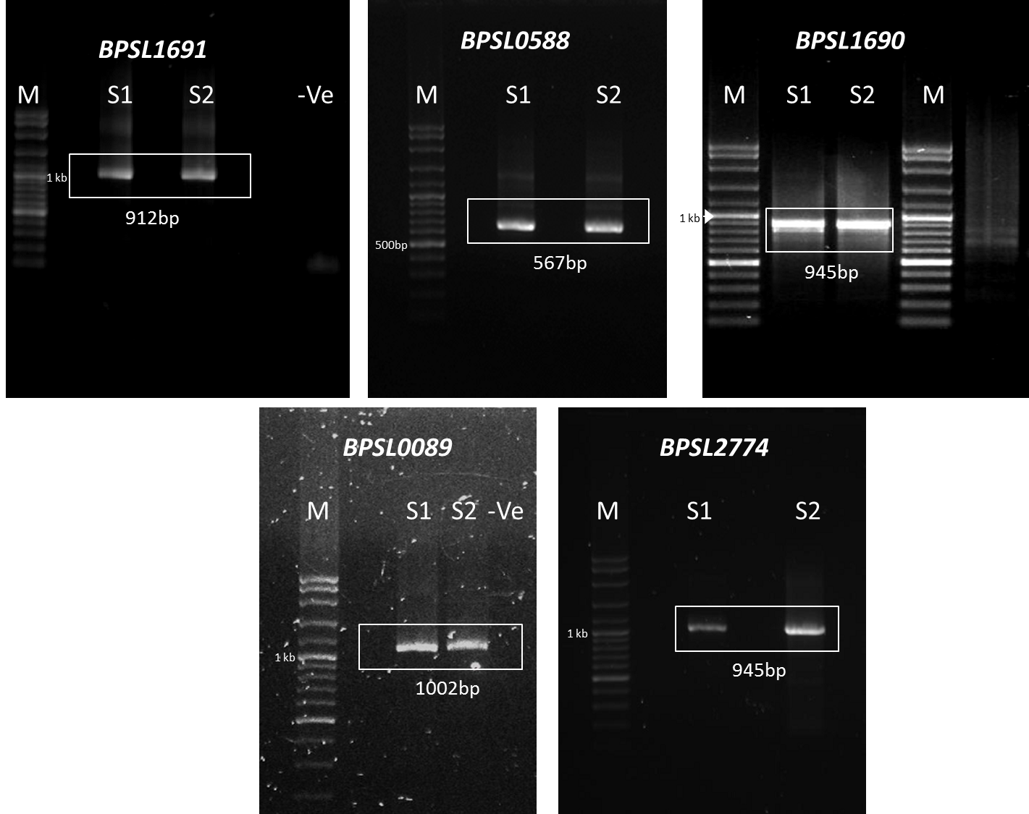

**Figure 1** PCR products for the five target gene constructs of *B. pseudomallei* target genes. Lane S1 and S2: sample replicates. M: 100bp plus molecular marker (Vivantis).

**3.2 Directional cloning using Gateway™ cloning system**

The PCR amplification and cloning results were summarized in Table 6. At the time of this report, two target genes, *BPSL0089* and *BPSL2774* were successfully cloned into pDONR221 vector*.* This was confirmed by colony PCR (data not shown) and *Bsr*GI restriction digest (Figure 2). This was further verified by DNA sequencing result compared to existing geneDB sequence database using ClustalX server. Despite successful DNA amplification for the other four target genes, we have yet to obtain successful cloning results after several attempts.

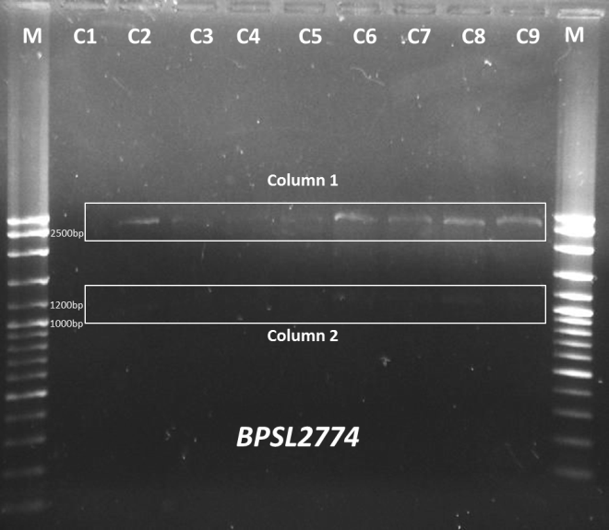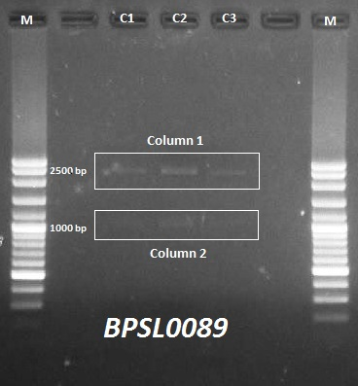

**Figure 2** BsrG1 Restriction Digest product for *BPSL2774*(left) and *BPSL0089* (right). Marker: 100bp Plus DNA ladder (Vivantis). Column 1: pDONR221 vector with size 2.5kb, Column 2: *BPSL2774* with size 945bp (left picture), *BPSL0089* with size 1002bp (right picture). C1-C9: colony numbering

**Table 6** Summaries of PCR Amplification and cloning results using Gateway system.

|  |  |  |  |  |  |  |  |
| --- | --- | --- | --- | --- | --- | --- | --- |
| **Target Gene** | **Nucleo-tide length** | **pI** | **Amino acid/ mass (kDa)** | **PDB BLASTp** | **Gateway PCR** | | **DNA Purity (A260/**  **A280)** |
| **Primestar® HS DNA Polymerase (Takara)** | **Optimal Annealing Temperature (ºC)** |
| *BPSL0588* | 567bp | 9.2 | 188/  22.0 | No similarity | ✓ | 58 | 1.88 |
| *BPSL0089* | 1002bp | 9.9 | 333/  37.3 | No similarity | ✓ | 58 | 1.85 |
| *BPSL1690* | 780bp | 5.4 | 259/  27.8 | Crystal Structure From *Neisseria Gonorrhoeae* (11%) | ✓ | 60 | 1.75 |
| *BPSL1691* | 912bp | 5.0 | 303/  32.9 | Crystal structure of a Duf692 Family Protein from *Haemophilus Somnus* (31%) | ✓ | 58 | 1.51 |
| *BPSL2774* | 945bp | 9.8 | 314/  35.1 | *Xanthomonas Campestris* Putative Ogt (17%) | ✓ | 56 | 1.86 |

**4.0 CONCLUSION**

In this study, five target genes selected from TraDIS predicted essential genes compilation (21) were successfully amplified. Two of the genes, *BPSL0089* and *BPSL2774* were successfully cloned using Gateway coning system. These verified entry clones are now being used for the subsequent LR reaction to produce expression clones that can be used for upcoming protein expression and purification experiments.

This study is conducted with the future aim to perform small-scale expression and purification screening on successfully cloned potential target genes from *B. pseudomallei* predicted by TraDIS. Protein will be expressed in bacterial cells and the soluble phase will be utilized for protein purification. Affinity binding tests will be performed to confirm expression and solubility.

Thus, this study is expected to produce several *B. pseudomallei* target genes that are readily expressed, soluble and can be utilized for large-scale protein purification. The purified, homogenous protein yields from large-scale protein purification can then be used for subsequent biochemical or biophysical detailed characterization in future.

**Acknowledgement**

We would like to thank all supporting laboratory staff at Kulliyyah of Science for their assistance. This study is funded by IIUM Endowment B research grant (EDW B 14-144-1029) and RAGS 14-036-0099 research grant from Malaysian Ministry of Education.

**References**

1. White, N. J. (2003). Melioidosis. *The Lancet*, *361*(9370), 1715-1722.
2. Novem, V., Shui, G., Wang, D., Bendt, A. K., Sim, S. H., Liu, Y., ... & Tan, G. (2009). Structural and biological diversity of lipopolysaccharides from *Burkholderia pseudomallei* and *Burkholderia thailandensis*. *Clinical and Vaccine Immunology*, *16*(10), 1420-1428.
3. Vellasamy, K. M., Vasu, C., Puthucheary, S. D., & Vadivelu, J. (2009). Comparative analysis of extracellular enzymes and virulence exhibited by *Burkholderia pseudomallei* from different sources. *Microbial pathogenesis*, *47*(3), 111-117.
4. Ashdown, L. R., & Koehler, J. M. (1990). Production of hemolysin and other extracellular enzymes by clinical isolates of *Pseudomonas pseudomallei*. *Journal of clinical microbiology*, *28*(10), 2331-2334.
5. Yang, H., W. Chaowagul, and P. A. Sokol. (1991). Siderophore production by *Pseudomonas pseudomallei.* Infect. Immun. 59:776–780.
6. Wiersinga, W. J., Van der Poll, T., White, N. J., Day, N. P., & Peacock, S. J. (2006). Melioidosis: insights into the pathogenicity of *Burkholderia pseudomallei.* *Nature Reviews Microbiology*, *4*(4), 272-282.
7. Vellasamy, K. M., Mariappan, V., Hashim, O. H., & Vadivelu, J. (2012). Functions of Burkholderia virulence factors: input from proteomics and DNA microarray analyses. *Journal Analytical Science and Technology*, *3*, 72-80.
8. Schweizer, H. P. (2012). Mechanisms of antibiotic resistance in Burkholderia pseudomallei: implications for treatment of melioidosis. *Future microbiology*, *7*(12), 1389-1399.
9. Maharjan, B., Chantratita, N., Vesaratchavest, M., Cheng, A., Wuthiekanun, V., Chierakul, W., ... & Peacock, S. J. (2005). Recurrent melioidosis in patients in northeast Thailand is frequently due to reinfection rather than relapse. *Journal of clinical microbiology*, *43*(12), 6032-6034.
10. Limmathurotsakul, D., Chaowagul, W., Chierakul, W., Stepniewska, K., Maharjan, B., Wuthiekanun, V., ... & Peacock, S. J. (2006). Risk factors for recurrent melioidosis in northeast Thailand. *Clinical infectious diseases*, *43*(8), 979-986.
11. Limmathurotsakul, D., Chaowagul, W., Chantratita, N., Wuthiekanun, V., Biaklang, M., Tumapa, S., ... & Peacock, S. J. (2008). A simple scoring system to differentiate between relapse and re-infection in patients with recurrent melioidosis. *PLoS Negl Trop Dis*, *2*(10), e327.
12. Limmathurotsakul, D., Paeyao, A., Wongratanacheewin, S., Saiprom, N., Takpho, N., Thaipadungpanit, J., ... & Peacock, S. J. (2014). Role of Burkholderia pseudomallei biofilm formation and lipopolysaccharide in relapse of melioidosis. *Clinical Microbiology and Infection*, *20*(11), O854-O856.
13. Chin, C. Y., Hara, Y., Ghazali, A. K., Yap, S. J., Kong, C., Wong, Y. C., ... & Nathan, S. (2015). Global transcriptional analysis of Burkholderia pseudomallei high and low biofilm producers reveals insights into biofilm production and virulence. *BMC genomics*, *16*(1), 1.
14. Holden, M. T. G., Titball, R. W., Peacock, S. J., Cerdeño-Tárraga, A. M., Atkins, T., Crossman, L. C. & Parkhill, J. (2004). Genomic plasticity of the causative agent of melioidosis, Burkholderia pseudomallei. Proceedings of the National Academy of Sciences of the United States of America, 101(39), 14240-14245.
15. Wiersinga, W. J., Currie, B.J., Peacock, S. J. (2012). Melioidosis. *The New England Journal of Medicine*, 367, 1035-1044.
16. Guo, F. B., Ye, Y. N., Ning, L. W. & Wei, W. (2015). Three Computational Tools for Predicting Bacterial Essential Genes. *Gene Essentiality: Methods and Protocols*, 205-217.
17. Acencio, M. L. & Lemke, N. (2009). Towards the prediction of essential genes by integration of network topology, cellular localization and biological process information. *BMC bioinformatics*, *10*(1), 290.
18. Ou, K., Ong, C., Koh, S. Y., Rodrigues, F., Sim, S. H., Wong, D., ... & Soon, S. Y. (2005). Integrative genomic, transcriptional, and proteomic diversity in natural isolates of the human pathogen Burkholderia pseudomallei. *Journal of bacteriology*, *187*(12), 4276-4285.
19. Langridge, G. C., Phan, M. D., Turner, D. J., Perkins, T. T., Parts, L., Haase, J., ... & Wain, J. (2009). Simultaneous assay of every Salmonella Typhi gene using one million transposon mutants. *Genome research*, *19*(12), 2308-2316.
20. van Opijnen, T., & Camilli, A. (2013). Transposon insertion sequencing: a new tool for systems-level analysis of microorganisms. *Nature Reviews Microbiology*, *11*(7), 435-442.
21. Moule, M. G., Hemsley, C. M., Seet, Q., Guerra-Assunção, J. A., Lim, J., Sarkar-Tyson, M., & Wren, B. W. (2014). Genome-Wide Saturation Mutagenesis of *Burkholderia pseudomallei* K96243 Predicts Essential Genes and Novel Targets for Antimicrobial Development. *MBio*, 5(1), e00926-13.
22. Chen, C., Chen, D., Sharma, J., Cheng, W., Zhong, Y., Liu, K., ... & Zhong, G. (2006). The hypothetical protein CT813 is localized in the *Chlamydia trachomatis* inclusion membrane and is immunogenic in women urogenitally infected with C. trachomatis. *Infection and immunity*, *74*(8), 4826-4840.
23. Hartley, J. L., Temple, G. F. & Brasch, M. A. (2000). DNA cloning using in vitro site-specific recombination. *Genome research*, *10*(11), 1788-1795.
24. Walhout, A. J., Temple, G. F., Brasch, M. A., Hartley, J. L., Lorson, M. A., van den Heuvel, S., & Vidal, M. (2000). [34] GATEWAY recombinational cloning: Application to the cloning of large numbers of open reading frames or ORFeomes. *Methods in enzymology*, *328*, 575-IN7.
25. Cheng, A. C., Stephens, D. P., Anstey, N. M. & Currie, B. J. (2004). Adjunctive granulocyte colony-stimulating factor for treatment of septic shock due to melioidosis. *Clinical infectious diseases*, *38*(1), 32-37.
26. Osman, A.L., Abdullah, S.M.S., Drahaman, S.M., Raih, M.F., Bunnori, N.M. and Rehan, A.M., 2015. DNA amplification optimization and cloning of several target genes from *Burkholderia pseudomallei*. *Jurnal Teknologi*, *77*(25).
27. Kuwayama, H., Obara, S., Morio, T., Katoh, M., Urushihara, H., & Tanaka, Y. (2002). PCR-mediated generation of a gene disruption construct without the use of DNA ligase and plasmid vectors. *Nucleic Acids Research*, *30*(2), e2-e2.
28. Song, Q., Lange, T., Spahr, A., Adler, G., & Bode, G. (2000). Characteristic distribution pattern of *Helicobacter pylori* in dental plaque and saliva detected with nested PCR. *Journal of medical microbiology*, *49*(4), 349-353.