**05**

**A PROPOSED BIOLOGICAL TREATMENT FOR WASTEWATER:**

**BIOGRANULATION OF METALDEHYDE**

Azlina Mat Saad*, Farrah Aini Dahalan, Naimah Ibrahim, & Sara Yasina Yusuf

School of Environmental Engineering, Universiti Malaysia Perlis,

Kompleks Pengajian Jejawi 3, 02600 Arau, Perlis, Malaysia.

**Abstract**

*Metaldehyde, a toxic molluscicide has been used extensively in agriculture to combat slugs and snails. This study will investigate the capability of aerobic granular sludge to degrade metaldehyde in wastewater. Aerobic granules will be cultivated in sequencing batch reactor (SBR) with total cycle of 24 hours. Synthetic wastewater with acetate as main carbon source will be used as feeding to the biomass in the reactor. The morphological and structural stability changes of microbial diversity in aerobic granular sludge exposed to toxic shock load of metaldehyde will be examined in this study. Parameters of wastewater such as mixed liquor suspended solid (MLSS), mixed liquor volatile suspended solid (MLVSS), settling velocity (SV), pH, chemical oxygen demand (COD) and biological oxygen demand (BOD) will be monitored using standard methods of American Public Health Association (APHA). Morphology of aerobic granular sludge will be analysed using scanning electron microscope (SEM).*

**Keywords*:*** *metaldehyde, wastewater treatment, aerobic granular sludge*

*Corresponding author: linasaad139@yahoo.com (e-mail), 019 - 5678 159 (H/P)

1. **Introduction**

In this study, aerobic granular sludge (AGS) developed in sequencing batch reactor (SBR) will be used to biodegrade metaldehyde from wastewater. The effectiveness of AGS to degrade metaldehyde will be monitored. Microbes in AGS will be utilized to decrease the toxic effect of metaldehyde. The ability of AGS to survive with high-strength organic compound is expected could biodegrade metaldehyde in wastewater efficiently. In addition, AGS was used in numerous studies to remove organic pollutants in drinking water.

The effect of metaldehyde on extracellular polymeric substances (EPS) will be investigated. Metaldehyde is used as molluscicide to kill golden apple snail in paddy field (MADA, 2014). Metaldehyde has been used extensively and brought concerns worldwide (Salleh et al., 2012). Metaldehyde is harmful to human and animals (ALS environment, 2014). This compound was found in surface water (Moreau et al., 2015).

Metaldehyde and its derivatives enter the bloodstream and effects on the central nervous system (INCHEM, 1996 and EXTOXNET, 1996). Acetaldehyde, effect on consciousness in animals (EXTOXNET, 1996). Sign shows such as salivation, and muscle spasms during poisoning doses of this compound (INCHEM, 1996). Metaldehyde cause effects to humans, animals and plants (Naqvi and Vaihnavi, 1993, Calumpang et al., 1995, and Becker et al., (2011).

On the other hand, metaldehyde also decrease the distribution of aquatic biota (Calumpang et al., 1995; Horgan et al., 2014). Therefore, there is a need on comprehensive study for the biodegradation of metaldehyde in water using AGS cultivated in SBR to provide clean and healthy water sources to human and the environment. The objectives of this study are: (i) to characterize the physical properties of AGS exposed to toxic shock load of metaldehyde. (ii) to determine microbial diversity in aerobic granular sludge. (iii) to examine the effect of metaldehyde on extracellular polymeric substances (EPS). (iv) to study the removal performance of metaldehyde.

In this study, a cylindrical column will be used as the bioreactor to develop AGS. Activated sludge will be used to start the granulation. Synthetic wastewater will be supplied into the reactor. The wastewater characteristics such as chemical oxygen demand (COD), ammoniacal nitrogen, mixed liquor suspended solid (MLSS), mixed liquor volatile suspended solid (MLVSS), sludge volume index and other parameters will be taken frequently. The inhibitory of extracellular polymeric substances (EPS) secretion and morphological changes of granular sludge exposed to shock load of metaldehyde will be examined in this study. EPS extraction method will be done by using formaldehyde and NaOH followed by protein determination using Lowry method. Besides that, optical microscope with digital camera, scanning electron microscope (SEM) and field emission scanning electron microscope (FESEM) will be used to monitor the morphology of AGS.

DNA extraction and PCR amplification will be done to screen morphological and structural stability changes of microbial diversity in AGS exposed to toxic shock load of metaldehyde. The importance of this study is to fundamentally study the effectiveness and diversity of the microbial community in treating paddy field wastewater.

This study will enrich the researches on biodegradation rate of pesticides with respect to metaldehyde in water. Other than that, this research will provide information whether AGS is suitable tool for assessing status of metaldehyde removal.

Additionally, the findings of this study will provide fundamental establishment, ecotoxicology and bioremediation solution on the wastewater containing metaldehyde. This study will benefit government and non-government bodies such as Muda Agricultural Development Authority (MADA), Indah Water Konsortium (IWK), Department of Irrigation and Drainage (DID) and Department of Environment (DOE).

1. **Research Methodology**
   1. **Study outline**

All the procedures that will be involved in this study starts from experimental set up to analysis were tabulated in Figure1.

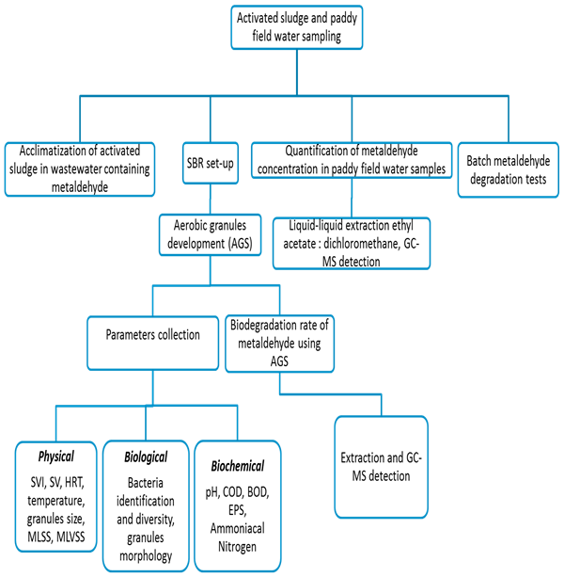

Figure 1: General overview of the study

* 1. **Reactor set -up and operations**

Experiment will be conducted in a cylindrical acrylic column bioreactor and had internal diameter of 10 cm with a total height of 30.5 cm and a total volume of 2.4 L. The working volume of 2.2 L will be used in this experimental study.

Two set of peristaltic pump will be used to feed and to discharge the synthetic wastewater in the reactor system. The influent will be introduced in the reactor through a port located at the bottom of the column. The effluent will be discharged through an outlet port which had a volumetric exchange ratio (VER) of 50% and located at the middle of reactor height. Air will be supplied at the bottom of the reactor by a fine air bubble diffuser during reaction time.

The reactor will be operated under sequencing batch mode for continuous operation of 24 h. at temperature (27 - 30 o C). 10 min of feeding from the bottom of the bioreactor without stirring, 120 min of aeration, 5 min of settling and 5 min of effluent withdrawal as shown in Figure 2. The nutrient removal performance will also be monitored to demonstrate the feasibility of using the aerobic granulation for treating the agricultural wastewater. The sludge retention time (SRT) will be discovered by the discharge of total suspended solids with the effluent. Figure 3 shows reactor set up in this study.

Figure 2: Sequencing batch reactor cycle phases

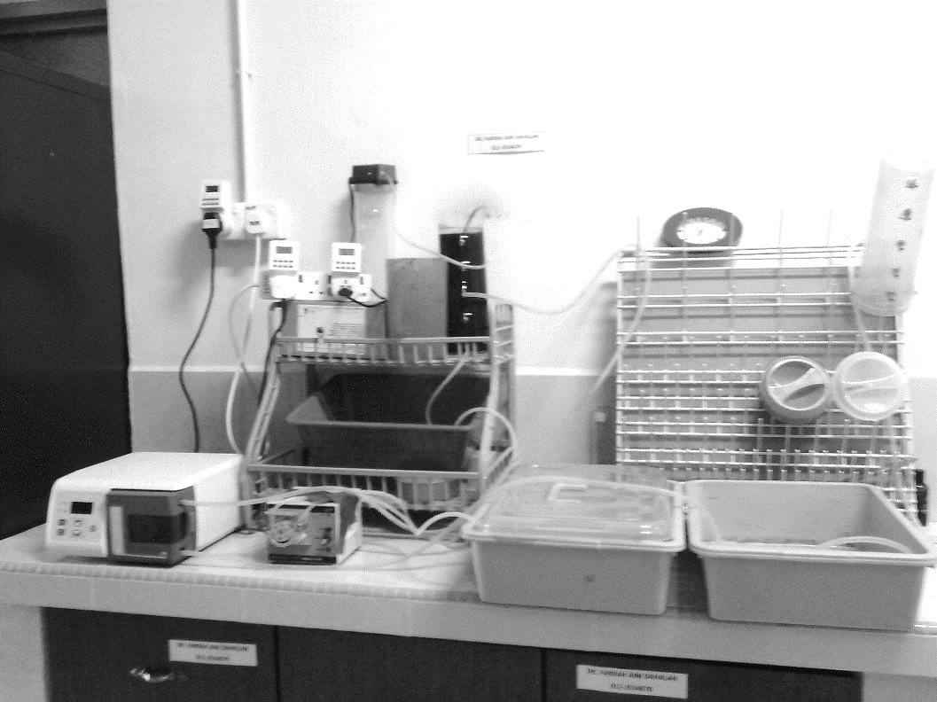

Peristaltic pump

Air pump

Plastic air diffuser

Digital timer

Reactor

In

Out

Figure 3: Reactor set up

* 1. **Synthetic wastewater characteristics and seed sludge sample preparations**

The reactor will be fed based on a similar recipe of synthetic wastewater attempted by Nor-Anuar et al. (2007). The COD - load with medium is 1.6 g COD/L/d and the COD/N ratio is 8.3. The synthetic wastewater recipe in this study is illustrated in Table 2.

Table 2: Composition of synthetic domestic wastewater

|  |  |
| --- | --- |
| Medium | Composition |
| *Medium O* |  |
| CH3COONa | 65.1 mM |
| MgSO4.7H2O | 3.7 mM |
| KCl | 4.8 mM |
| *Medium N* |  |
| NH4Cl | 35.2 mM |
| K2HPO4 | 2.2 mM |
| KH2PO4 | 4.4 mM |
| *Trace element*  EDTA  FeSO4.7H2O  ZnSO4.7H2O  CaCl2.2H2O  MnCl2.4H2O  CuSO4.5H2O  COCl2.6H2O | 100 g  1 g  4.5 g  16.4 g  10.1 g  3 g  3 g |

Source: Anuar et al. (2007)

* 1. **Analytical method parameters**

The characteristics of the wastewater will be analysed according to Standard Methods 2540-E (APHA, 2005). For the microscopic examinations, the AGS will be separated using three different size of mesh sieve (0.2, 0.4 and 0.6mm) (Dahalan et al., 2015).

* 1. **Determination of metaldehyde**

Liquid-liquid extraction using separatory funnel method is based on US EPA Method 3510 for aqueous matrix for the analysis of semi-volatile and non-volatile organics (US EPA, 2004). The extracts will be cleaned up by using the US EPA Method 3620B (US EPA, 1989).

**Acknowledgement**

The authors wish to thank:

1. Government of Malaysia and Ministry of Education Malaysia for the Fundamental Research Grant Scheme (FRGS) No. 9003-00386.
2. Universiti Malaysia Perlis for the financial aid through Postgraduate Academic Activities Fund (PAAF).

**References**

Anuar, A. N., Ujang, Z., Van Loosdrecht, M. C. M., & De Kreuk, M. K. (2007). Settling behaviour of aerobic granular sludge. *Water Science and Technology, 56*(7), 55-63.

ALS Environment (2014). Determination of metaldehyde in water. Retrieved May 4, 2014, from https://www.researchgate.net/file.PostFileLoader.html?id=5663bdec6225ff62f6 8b4567&assetKey=AS%3A303524385099776%401449377260246.

APHA (American Public Health Association). (2005). Standard Methods for the Examination of Water and Wastewater. 21st Edition. New York: American Public Health Association, the American Water Works Association and the Water Environment Federation.

Becker, L., Scheringer, M., Schenker, U., & Hungerbühler, K. (2011). Assessment of the environmental persistence and long-range transport of endosulfan. *Environmental Pollution, 159*(6), 1737-1743.

Calumpang, S. M. F., Medina, M. J. B., Tejada, A. W., & Medina, J. R. (1995). Environmental impact of two molluscicides: niclosamide and metaldehyde in a rice paddy ecosystem. *Bulletin of Environmental Contamination and Toxicology, 55*(4), 494-501.

Dahalan, F. A., Abdullah, N., Yuzir, A., Olsson, G., Hamdzah, M., Din, M. F. M., ... & Ujang, Z. (2015). A proposed aerobic granules size development scheme for aerobic granulation process. *Bioresource Technology, 181*, 291-296.

EXTOXNET (The EXtension TOXicology NETwork). (1996). Extension toxicology network pesticide information profiles – Metaldehyde. Retrieved June 16, 2014, from http://extoxnet.orst.edu/pips/metal deh.htm.

Frølund, B., Palmgren, R., Keiding, K., & Nielsen, P. H. (1996). Extraction of extracellular polymers from activated sludge using a cation exchange resin. *Water Research, 30*(8), 1749-1758.

Horgan, F. G., Felix, M. I., Portalanza, D. E., Sánchez, L., Rios, W. M. M., Farah, S. E., Witherb, J. A., Andradeb, C. I., & Espin, E. B. (2014). Responses by farmers to the apple snail invasion of Ecuador's rice fields and attitudes toward predatory snail kites. *Crop Protection, 62*, 135-143.

INCHEM. (1996). Extension toxicology network. "Pesticide information profile - Metaldehyde". Retrieved June 13, 2015, from http://www.toxipedia.org/display/ toxipedia/Metaldehyde.

MADA (Muda Agricultural Development Authority). (2014). Siput Gondang Emas. Retrieved August 20, 2015, from http://mada.gov.my/siput-gondang-emas1.

Moreau, P., Burgeot, T., & Renault, T. (2015). In vivo effects of metaldehyde on Pacific oyster, Crassostrea gigas: comparing hemocyte parameters in two oyster families. *Environmental Science and Pollution Research, 22*(11), 8003-8009.

Naqvi, S. M., & Vaishnavi, C. (1993). Bioaccumulative potential and toxicity of endosulfan insecticide to non-target animals. *Comparative Biochemistry and Physiology Part C: Comparative Pharmacology, 105*(3), 347-361.

Salleh, N. H. M., Arbain, D., Daud, M. Z. M., Pilus, N., & Nawi, R. (2012). Distribution and management of *Pomacea canaliculata* in the Northern region of Malaysia: mini review. *APCBEE Procedia, 2*, 129-134.