INTERNATIONAL CONFERENCE ON POSTGRADUATE RESEARCH 2015 (ICPR2015)

Name of Author Institution Email

Name of Author Institution Email

ABSTRACT

The International Conference on Postgraduate Research 2015 (ICPR2015) offers researchers not only postgraduate students but also researchers who are interested to present papers on the system, curriculum and management of postgraduate school. This conference basically focuses on the area of postgraduate development and social sciences realizing the demand on this field and to explore the global issues. The researchers will be able to get feedback on their own work. It also enhances academic exchanges among researchers and also among students all over the world. The research activities of researchers and postgraduate students are geared towards achieving excellence in research and development. It is essential to provide a platform for the researchers and postgraduate students to present, question and exchange knowledge in the field of postgraduate research and social sciences.

Keywords: Postgraduate, researchers, social sciences.

1. Introduction/Background
The objectives of the conference is to provide a platform for the researchers and students to seek
further opinions, comments and suggestions towards the improvement of the conducted research, to contribute knowledge in the field of postgraduate research and social sciences and to provide wider opportunities to academicians and post graduate students to interact and create networking.

2. Literature Review
The International Conference on Postgraduate Research 2015 (ICPR2015) offers researchers not
only postgraduate students but also researchers who are interested to present papers on the system, curriculum and management of postgraduate school. This conference basically focuses on the area of postgraduate development and social sciences realizing the demand on this field and to explore the global issues. (Author, 2015)

3. Methodology, Findings, Analysis and Discussion
3. 1 Methodology
The researchers will be able to get feedback on their own work. It also enhances academic
exchanges among researchers and also among students all over the world. The research activities
of researchers and postgraduate students are geared towards achieving excellence in research and development.
Figure 1: Theoretical Framework

3.2 Findings and Analysis
It is essential to provide a platform for the researchers and postgraduate students to present,
question and exchange knowledge in the field of postgraduate research and social sciences.

Example of Table

Table1: Level of Urbanisation by State, Malaysia

Rank State Level Of Urvanization(%)

1 | Kuala Lumpur | 100
2 | Selangor | 91.4
3 | Penang | 90.8
4 | Melaka | 86.5
5 | Johor | 71.9
6 | Perak | 69.7
7 | N.Sembilan | 66.5
8 | Kedah | 64.6
9 | Terengganu | 59.1
10 | Sabah | 54.0
11 | Sarawak | 53.8
12 | Pahang | 50.5
13 | Kelantan | 42.4
Source: Department Of Statistic, Malaysia (2010)

EXAMPLE OF FIGURE
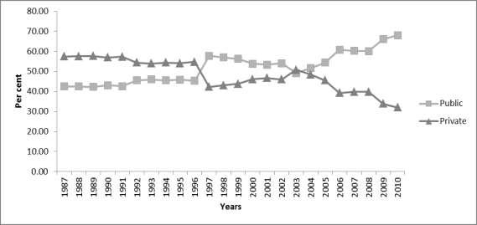
Figure 1: Share of Doctors in Public and Private Practices.
(Source: Ministry of Health, various years)
3.3 Discussion
The objectives of the conference is to provide a platform for the researchers and students to
seek further opinions, comments and suggestions towards the improvement of the conducted research, to contribute knowledge in the field of postgraduate research and social sciences
and to provide wider opportunities to academicians and post graduate students to interact and create networking.

4. Conclusion, Limitations and Recommendations
The International Conference on Postgraduate Research 2015 (ICPR2015) offers researchers
not only postgraduate students but also researchers who are interested to present papers on the system, curriculum and management of postgraduate school. This conference basically focuses on the area of postgraduate development and social sciences realizing the demand on this field and to explore the global issues.

Acknowledgement
This paper is under scholarship of the university.

References
Author, A. (2015). International Conference on Postgraduate Research 2015, Journal of
Management and Muamalah, Vol. 1, 123-133

