**TITLE OF ABSTRACT: (FONT: TIMES NEW ROMAN, FONT: SIZE-14 POINT, BOLD, CAPITAL LETTERS, CENTRED PARAGRAPH and SPACING: 1.0)**

First Author1, Second Author2, Third Author3 (Font: Times New Roman, font size-12 point, centred paragraph) (Maximum of 6 Authors)

*1University / Institution,*

*2University / Institution*

*3University / Institution*

*(Font: Times New Roman, font size:11 point, italic, centred paragraph)*

*Author’s email: *xxx@xxx.edu.my (Font: Times New Roman, font size-11 point, italic, centred paragraph)*

**Abstracts:** An abstract is a single paragraph, a compendious summary of a paper’s substance in 150 to 300 words, including background, purpose, methodology, findings, and conclusions. The main text for the abstract/summary uses the Times New Roman font, size-11 point. Type or paste your text into this file but remember to maintain the same margin as set here which is 2.54 cm. The paragraph should be justified (straight-edged) on the left and right. Use one line spacing. Do not include figures or references in the abstract/summary. Abstracts can be in English, Malay or Arabic.

**Keywords:** (Not more than 5 keywords) (Please use semicolon as separator)

**1. INTRODUCTION** (Font style: Times New Roman & Bold; Font Size: 12)

Before starting the first paragraph, one spacing after the header is a must. In the last paragraph of introduction section, authors should highlight the gap and significant of the research before writing the objective of the research. These three items are very important and compulsory.

**2. METHODOLOGY**

*2.1 Figure Style and Format*

For a full paper publication, all provided figures must follow the standard of quality for publication. Authors must provide a high quality with high resolution figure. Content in the figure should be clear and readable as shown in Figure 1(b) (Especially, the font size of contour legend). For example, as in Figure 1

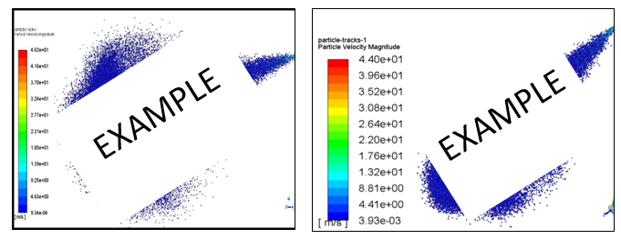

(a) (Font style: Times New Roman; Font size: 10) (b) (Font style: Times New Roman; Font size: 10)

**Fig. 1.** Figure quality (a) Unclear and unreadable content (b) Clear and readable content (Font style: Times New Roman; Font size: 11; Paragraph: Align left/Justify)

Each figure must be discussed or mentioned in a body paragraph. The figure must be placed under the paragraph that discussed about the figure. Authors should try to make economical use of the space on the page; for example,

1. avoid excessively large white space borders around your graphics;
2. try to design illustrations that make good use of the available space—avoid unnecessarily large amounts of white space within the graphic;
3. Use the suitable size of figure. Not too big.
4. Individual figures should normally be centred but place two figures side-by-side if they will fit comfortably as shown in the example above, as it saves space.

*2.2 Table Style and Format*

Table should be placed at the centre. Each table must be discussed or mentioned in a body paragraph. The table must be placed under the paragraph that discussed about the Table. Font style and font size of content in the table are Times New Roman and 10, respectively. The content must be aligned left. The font size of table caption is 11. The caption SHOULD NOT be finished with a full stop (period). The captions should be set to the width or within of the table.

**Table 1**

Place the caption above the table. Here the caption is wider than the table

|  |  |
| --- | --- |
| Distance (m) | Velocity (ms–1) |
| A | 1 |
| B | 2 |
| C | 3 |
| D | 4 |

**3. RESULTS AND DISCUSSIONS**

In result and discussion part, author should highlight the details result of their research and elaborate the results. **For example**: The experimental data of UTM-LST VFE-2 model at high angle of attack is presented here. More experiments are needed to verify this complicated flow topology.

**4. CONCLUSIONS**

In conclusion part, author should highlight the finding of their research that respond to the research objective. **For example**: The experimental data of UTM-LST VFE-2 model at high angle of attack is presented here. More experiments are needed to verify this complicated flow topology.

**5. ACKNOWLEDGEMENT**

This research was funded by a grant from Ministry of Higher Education of Malaysia (FRGS Grant R.J130000.7824.4X172). Special thanks to those who contributed to this project directly or indirectly.

**REFERENCES** (**Reference style: APA style**)

1. Y. Nasir, Y. J. Farizuan, Y. S. Zhu and H. Dang, International Journal of Atmospheric Environment 41, 13-19 (2015).
2. C. Kinlin, “The Future of Asian Optical Communication” (Conference on Optical Fiber Communication & Optoelectronic Exposition & Conference, (2006), pp. 1-3.
3. A. J. Kinloch, “Adhesion and Adhesives: Science and Technology” (Springer Science and Business Media, 1987).

**NOTE:**

**Please make sure all pictures/graphs are clear and readable. Do not insert page number for all manuscripts.**