**TITLE OF THE PAPER**

**(TIMES NEW ROMAN, 14 FONT SIZE, BOLD, ALL CAPS, CENTERED)**

Author

Affiliation

E-mail

Example:

Muhamad Fairuz Ali

Kolej Universiti Islam Pahang Sultan Ahmad Shah

E-mail: [mfairuz@kuipsas.edu.my](mailto:mfairuz@kuipsas.edu.my)

Che Radiah Mezah

Fakulti Bahasa Moden dan Komunikasi, Universiti Putra Malaysia

E-mail: [cradiah@upm.edu.my](mailto:cradiah@upm.edu.my)

Mohd Sukki Othman

Fakulti Bahasa Moden dan Komunikasi, Universiti Putra Malaysia

E-mail: [msukki@upm.edu.my](mailto:msukki@upm.edu.my)

*Enter*

*Enter*

**ABSTRACT**

*Enter*

Abstract should be written in 250 words and with 10 font size, Times New Roman, justified, single line spacing. Objectives, methods and findings are summarized in this section.

*Enter*

**Keywords:** Keywords regarding the work are stated in this section. Said section should contain maximum 5 words that are written with 10 font size, Times New Roman and seperated with semi-colon.

1. INTRODUCTION (Bold, Times New Roman, 12)

Welcome to PASAK 2025 The Conference is a primary international. (Times New Roman, Justify, 12, spacing 1.0). **The article must not exceed 5 pages, including references.**

1. METHODS (Bold, Times New Roman, 12)

All materials and methods that have been used in the work must be stated clearly and subtitles should be used when necessary. (Times New Roman, Justify, 12, spacing 1.0).

* 1. **Subtitle**

First degree titles (2.) should be written left aligned, all caps and bold. Second and 3rd degree subtitles (2.1, 2.1.1) should be written left aligned, bold and with title case. A blank line should be placed between the paragraphs and there should not be any paragraph indentation. (Times New Roman, Justify, 12, spacing 1.0).

1. RESULTS AND DISCUSSION (Bold, Times New Roman, 12)
   1. Subtitle

All of the tables, images and figures should be centered. Figures and images should be numbered together (Figure 1) and figure definitions should be placed under the figure or image; as for the tables, they should also be numbered (Table 2) and the table header should be placed at the top of the chart. Table, image and figure headers should be written with upper case initial letters, bold and should be centered. References (if any) of the tables, figures and images should be presented just under the tables, figures and images in the form of author surname and publication date.(Times New Roman, Justify, 12, spacing 1.0).

**Figure 1. Genders of spaceship crew members in popular television series** (Bold, Times New Roman, 12, Center)

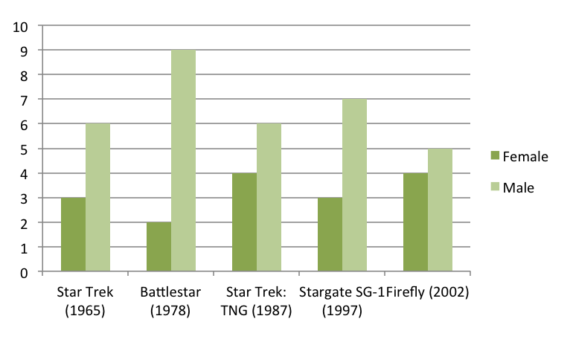

**Table 2: The Distribution of Teachers in Sabah and Sarawak**

(Bold, Times New Roman, 12, Center)

|  |  |  |  |
| --- | --- | --- | --- |
| No. | Location | Sabah | Sarawak |
| 1. | Kapit |  | 34 |
| 2. | Semariang |  | 24 |
| 3. | Kudat | 45 |  |
| 4. | Sandakan | 12 |  |

1. CONCLUSION (Bold, Times New Roman, 12)

Please conclude your work incorporating your most important finding as well as future works. (Times New Roman, Justify, 12, spacing 1.0)

1. ACKNOWLEDGEMENT

Please acknowledge your research grant, organization, scholarship (if applicable) (Times New Roman, Justify, 12, spacing 1.0)

1. REFERENCES (Bold, Times New Roman, 12, APA style)

1. Journal Article:

Format: Author(s). (Year). Title of the article. *Title of the Journal*, volume(issue), page range. https://doi.org/xxxx

Example: Wan Mohd Nor Wan Daud, & Khaliff Muammar. (2009). A comprehensive framework of 17th century Malay thought based on *Durr al-Faraid* by Sheikh Nurudin al-Raniri. *Sari-International Journal of the Malay World and Civilisation*, 27(2), 119-146. https://doi.org/xxxx

2. Book:

Format: Author(s). (Year). *Title of the book* (Edition, if applicable). Publisher.

Example: Strunk, W., Jr., & White, E. B. (1979). *The elements of style* (3rd ed.). Macmillan.

3. Book Chapter:

Format: Author(s) of the chapter. (Year). Title of the chapter. In Editor(s) (Ed(s).), *Title of the book* (pp. page range). Publisher.

Example: Mettam, G. R., & Adams, L. B. (1994). How to prepare an electronic version of your article. In B. S. Jones & R. Z. Smith (Eds.), *Introduction to the electronic age* (pp. 281-304). E-Publishing Inc.

4. Website:

Format: Author(s). (Year, Month Day). Title of the webpage. *Website name*. URL

Example: Smith, J. (1999, July 7). One of Volvo's core values. *Volvo*. <https://www.volvo.com/environment/index.htm>